

TCS5JB
Top-Up Switch

Installation and Operation Manual

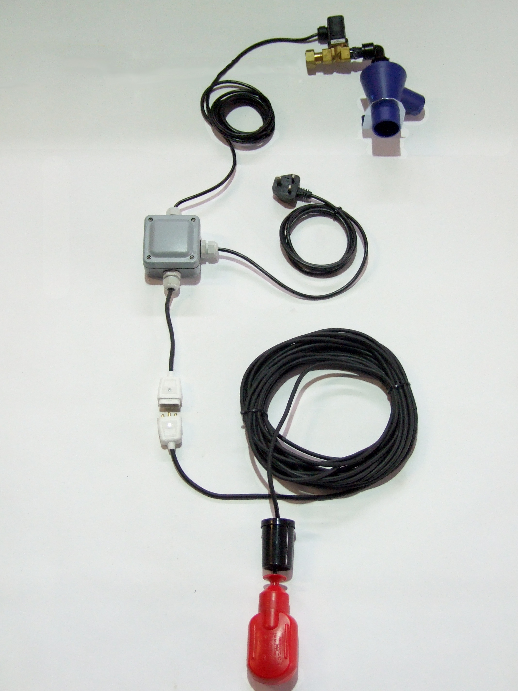

Description of Operation
The 3P Rainwater Top-up Switch is intended to ensure the availability of water in a rainwater tank by topping up the tank when the level becomes low, with a measured amount of mains water.

Water level in the tank is sensed via a float switch, and top-up of mains water is achieved via a solenoid valve connected to the mains water supply, feeding back to the rainwater tank from the building.

The solenoid will be activated when the float switch reaches a downward angle of approx 45deg or more, the top-up cycle will then continue until the float switch reaches an upward angle of approx 45deg, thereby ensuring a measured quantity of water is introduced to the tank and avoiding unnecessarily frequent top-ups.

The supplied tundish is a mandatory requirement in the UK designed to prevent contamination of the mains water supply when introducing mains water to a rainwater system.

Supplied Components
* Float-switch with weight, 2m, 15m or 20m cable, and connector.
* Top-up control box
* Solenoid valve with 2 metre cable.
* Tundish and bracket with elbow, back-nut and double nipple (1/2” & 3/4” versions only)
* 1.8 metre power cable with moulded plug.

Installation

Safety Precautions
Mains Voltage – There are exposed electrical conductors inside this appliance. This appliance must be installed and serviced by a competent electrical technician to the current requirements of BS7671 and IEEE recommendations. Before servicing this appliance, normal safe isolation procedures should be implemented.

Do not touch any connection terminals while energised.

Do not attempt to service this item when wet, or in a wet or high humidity environment.

If the housing of the control panel becomes damaged, you must shut down and securely isolate this appliance immediately.

Control Unit
The control box, solenoid valve and tundish should be installed indoors, in a location protected from freezing temperatures. It is small enough to be situated beneath a kitchen sink or unit, although other common locations for installation include utility rooms and adjoining garages. The most convenient location is often dictated by the location of the service duct supplying the rainwater tank, as this is typically the route by which mains water will be fed into the tank via a 50mm pipe or hose. All components are designed for wall mounting.

To fit the control box, loosen the 4 screws retaining the front cover, and remove the cover from the unit.

Fasten the control box to the wall via the 4 holes provided, and using appropriate fixings for the wall construction.

Replace the cover and tighten the 4 retaining screws, ensuring the waterproof seal is correctly positioned and is not pinched by the cover.

Tundish and Solenoid Valve
The tundish and solenoid are held via a steel bracket. Before attaching the bracket to the wall, bolt the tundish retaining clip to the bracket using the nut and bolt provided, do not tighten the bolt at this stage.

Fasten the bracket to the wall using appropriate fixings for the wall construction.

Slot the tundish into the bracket and rotate the tundish retaining clip such that it holds the tundish in place.

Using the back-nut provided, attach the solenoid valve to the top of the tundish bracket.

Versions supplied without a tundish and bracket should have the solenoid mounted so as to include and air gap compliant with BS EN 13076:2003.

Float Switch
Connect the float switch into the corresponding coloured socket attached to the control box.

The float switch is installed in the rainwater tank, and switches the controller on when hanging downward at an angle of 45 degrees or more. It will then switch off when the float lies upwards at an angle of 45 degrees or more. For this reason you must ensure that the weight supplied is set correctly in order that the float pivots around a fixed level. If this is not done, the float is likely to sit horizontally on the surface of the water until the tank is full, which wastes water and may cause the tank to overflow.

Adjustment
The amount of water topped up into the tank can be adjusted by moving the weight relative to the float. A shorter distance results in less water being topped up, a longer distance will top up with more water.

You should ideally top up with only a minimal amount of water. However, allowing a greater amount of top-up water can help to meet peak demands where the pump may be drawing water faster than the solenoid can fill the tank. This can be a particular issue in areas where mains water pressure may be low, or where water is used at a high rate, such as washing down yards, filling bowsers, etc.

NOTE – This control unit does not control the operation of the pump. Therefore if the tank is initially empty when the system is powered up, then the top-up switch must be allowed to complete a top-up cycle before the pump is powered up, thus avoiding the possibility of the pump running dry. A control unit with pump control is available, please contact your supplier for details.

Operation

Safety Precautions
Mains Voltage – There are exposed electrical conductors inside this appliance. This appliance must be installed and serviced by a competent electrical technician to the current requirements of BS7671 and IEEE recommendations. Before servicing this appliance, normal safe isolation procedures should be implemented.

Do not touch any connection terminals while energised.

Do not attempt to service this item when wet, or in a wet or high humidity environment.

If the housing of the control panel becomes damaged, you must shut down and securely isolate this appliance immediately.

Adjustments
Operation is automatic. There are no adjustments to be made at the control unit.

Non-weighted float cables

The level around which the system starts and stops the top-up cycle can be adjusted by moving the point at which the float cable is attached within the tank.

The top-up duration can be adjusted by increasing or decreasing by the length of free cable to the float.
Weighted float cables

If your float switch has a weight attached along it's length, the position of that weight can be adjusted. You may need to secure it with a cable tie.

The level around which the system starts and stops the top-up cycle can be raising or lowering the float into the tank.

The top-up duration can be adjusted by increasing or decreasing by the length of free cable between the float and the weight.

Specifications
Control Unit
Dimensions 130 x 94 x 57mm (excluding cable entries)
Supply Voltage 230-240Vac 50Hz
Supply Cable 2m
Pump Supply 10A max
Ingress Protection IP66
Material Polystyrene

Solenoid
Supply voltage 230-240 Vac 50 Hz
Connection cable 2 m
Power consumption 5.5 VA to 20VA
Medium Clean water
Mounting position Wall mount
Function Normally Closed
Max pressure 12 bar
Ingress Protection IP54 or above

